Kuo Chuan Presbyterian Secondary School
Sec 2 Subject Combination Mock Exercise

URL : https://kuochuan.schoolhub.sg

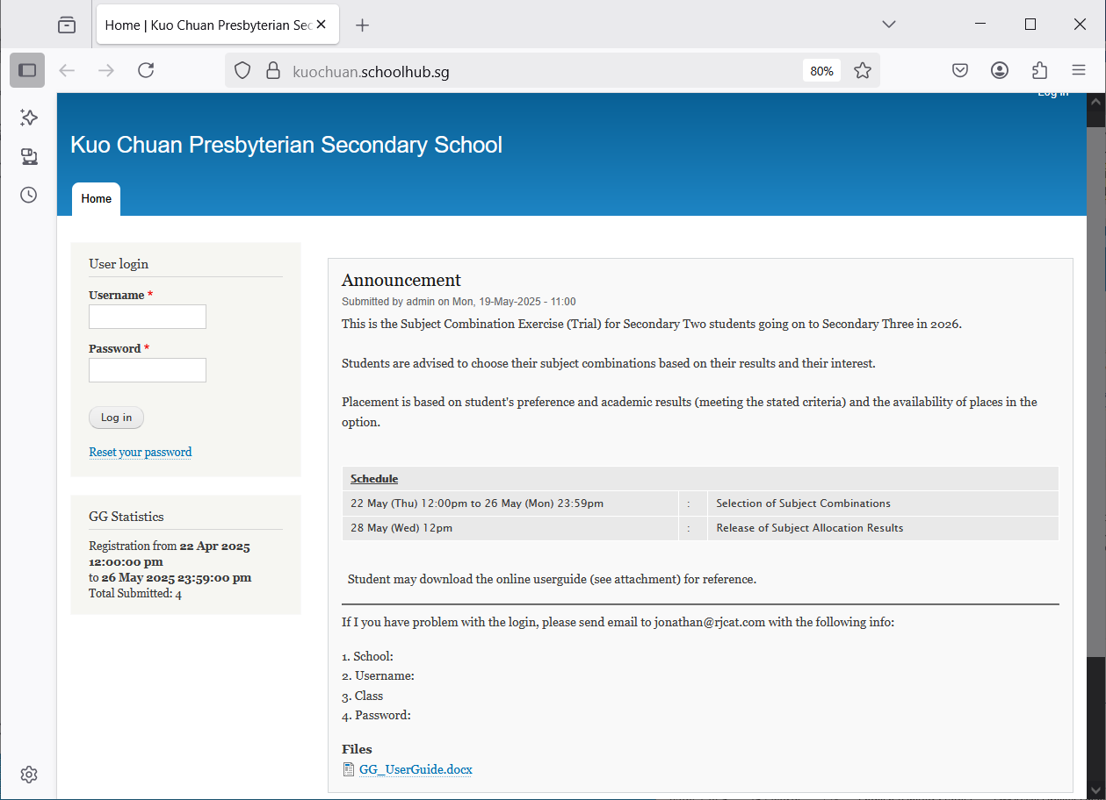

Steps
- Enter Username
- Enter Password
- Click Login

Register Choices

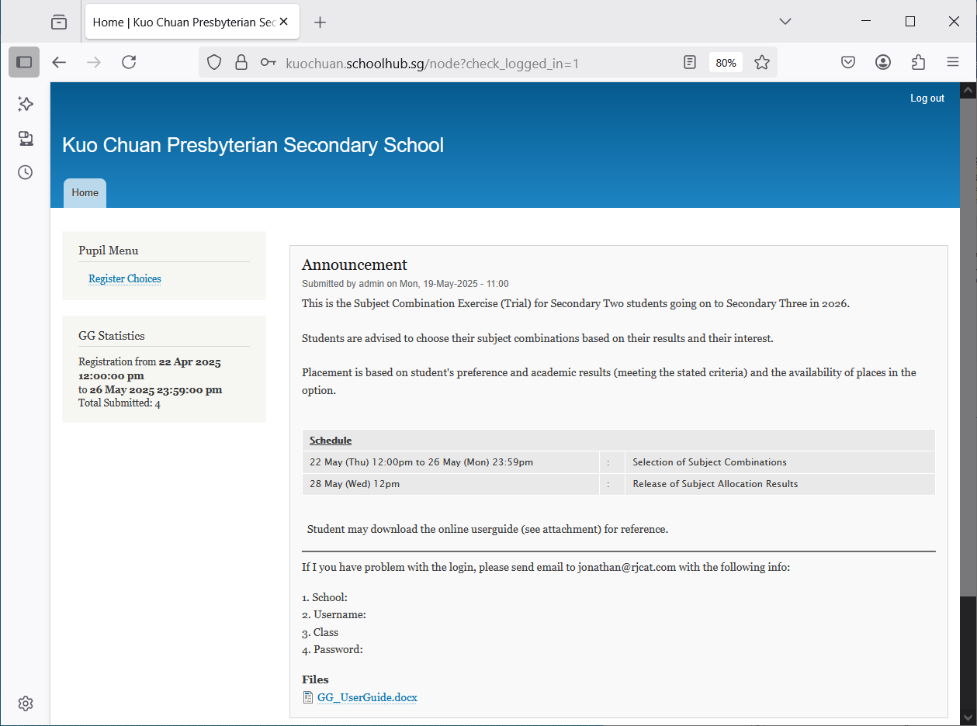

Steps
- Click Register Choices

The subjects are divided into different categories:
- EL - Compulsory
- MT - Compulsory
- MATH - Compulsory
- COMBINED HUMANITIES
- SCIENCE
- OTHERS
You will need to rank all the subjects within each category. Please note that only subjects offered to you will be available for you to rank. For categories with only ONE Subject (Compulsory), it will be automatically rank 1.

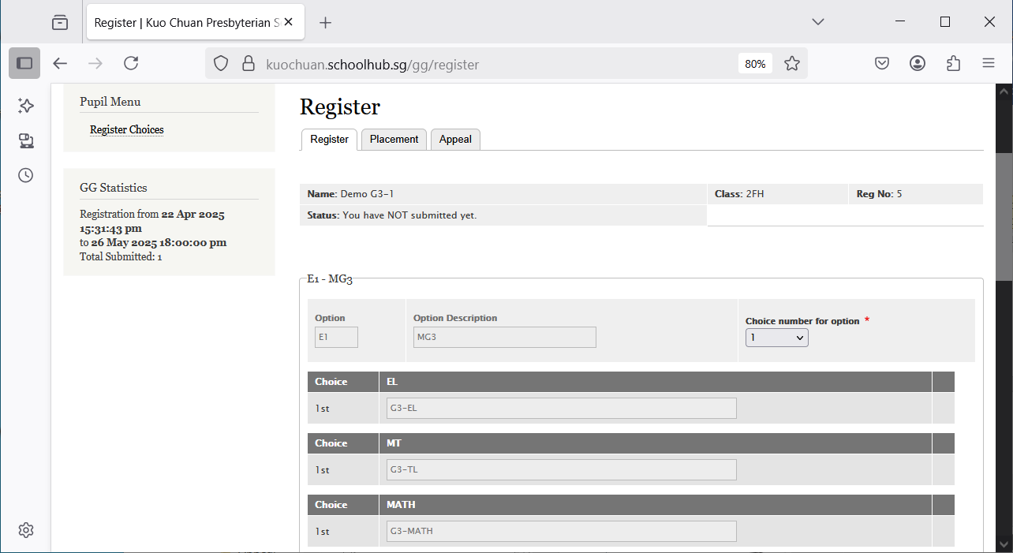

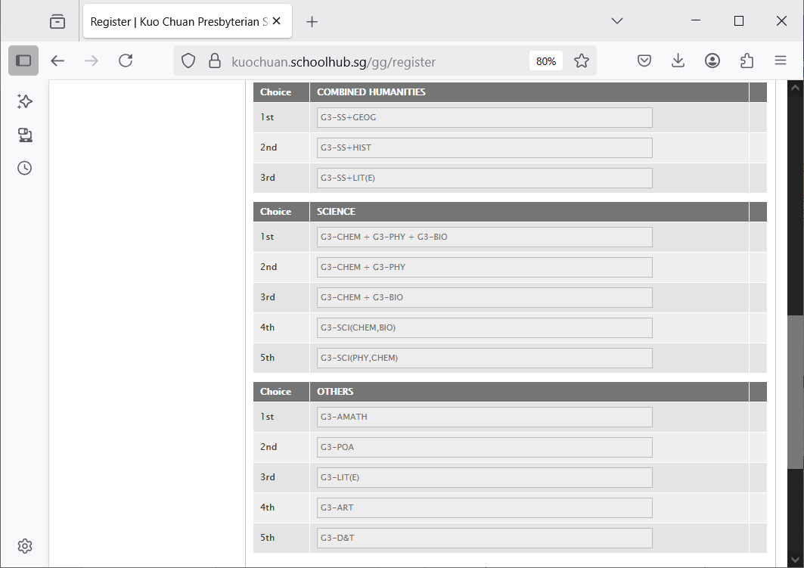
Hold and Drag to change your choices.
for example:
Change G3-SS-Hist to 1st choice
Change G3-SS+Geog to 2nd Choice

After changes:

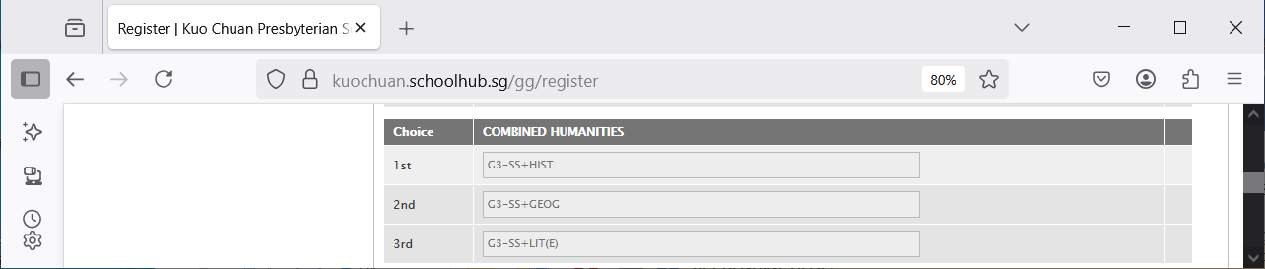
1st Choice = G3-SS+HIST
2nd Choice = G3-SS+GEOG
3rd Choice = G3-SS+LIT(E)

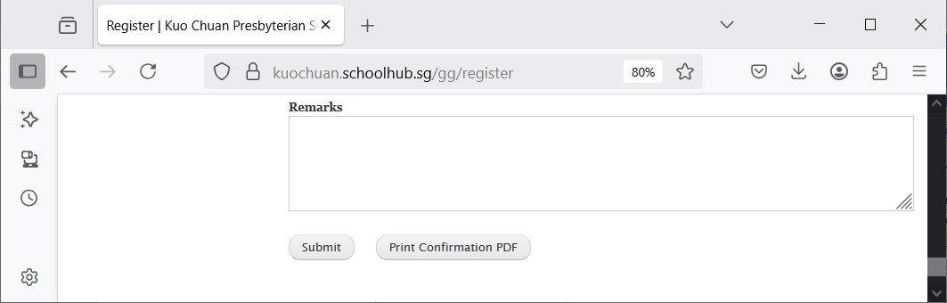
Click Print Confirmation PDF to get a copy of the PDF for your reference.
Click Submit to save your choices. You may change them before the closing date.
Enter any remark you wish to communicate with your teacher

Sample Confirmation Slip

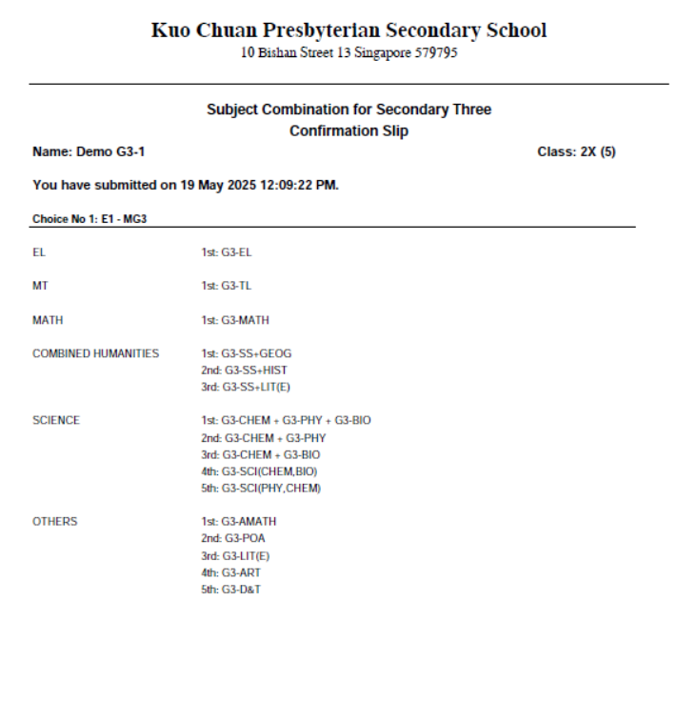

Check Subject Allocation

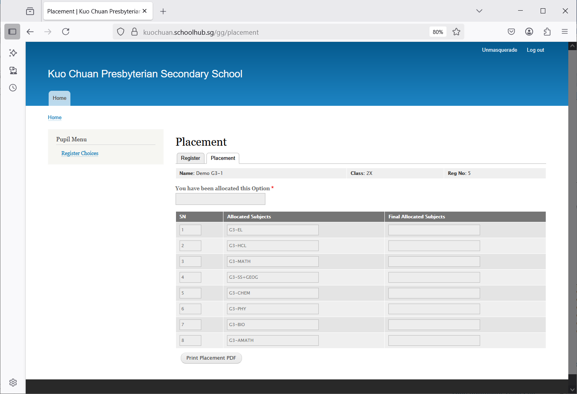
Click Print Placement PDF your reference.
Click Placement

Sample Placement Slip

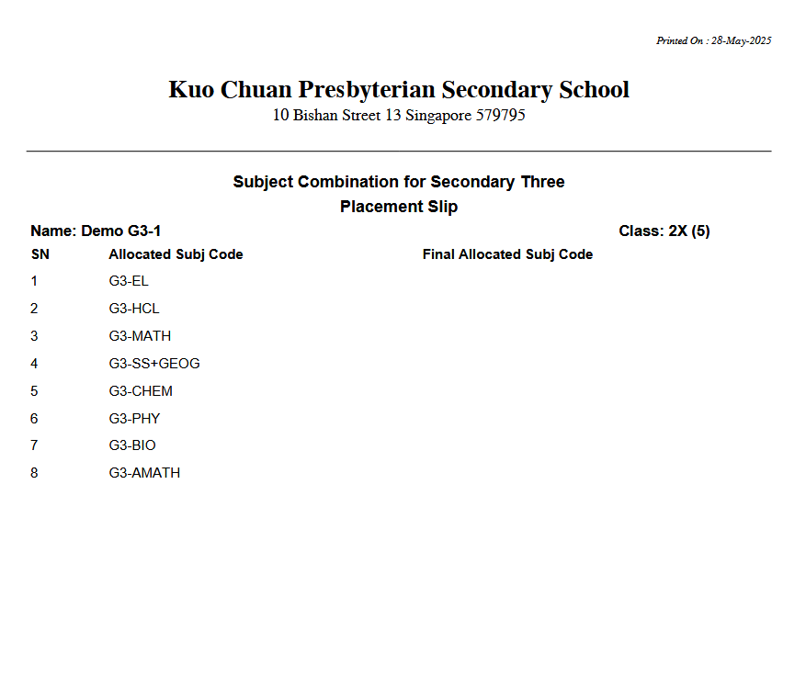

Appeals

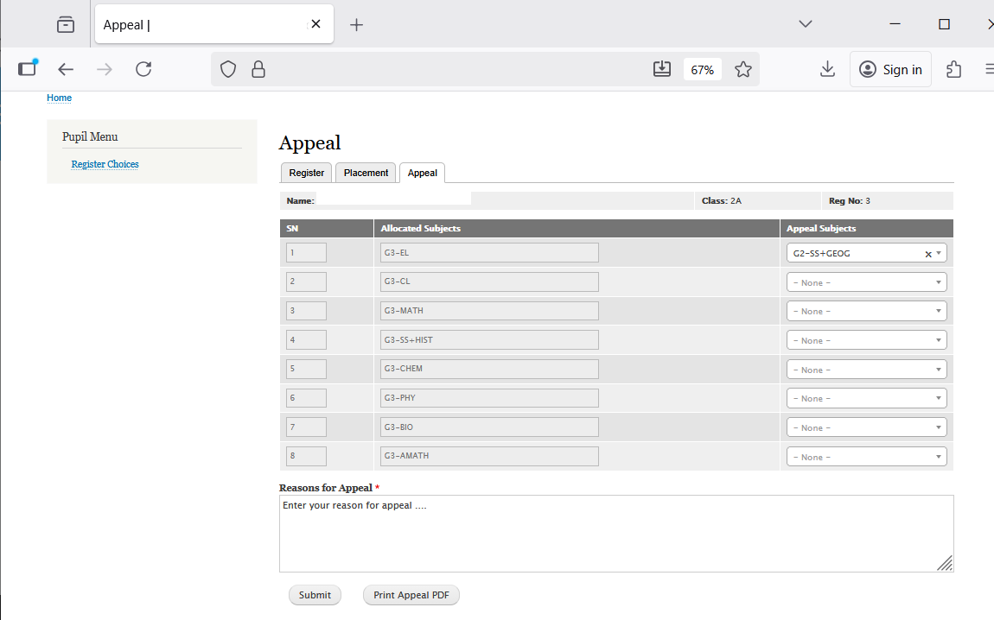
Select Subject to Appeal for
Indicate reasons for the Appeal
You may print a copy for your reference

Check Final Subject Allocation

If there is no APPEAL, the Final Allocated Subjects will be the same as the Original Allocated Subjects.

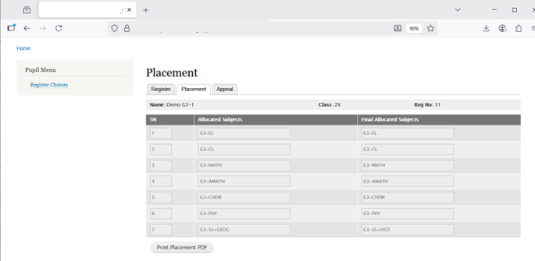
Final Allocated Subjects
Original Allocated Subjects
You may print a copy for your reference

